PROGRAMME CATEGORY | GUEST LECTURE (FOR THE STUDENTS OF TDC)
NAME OF THE PROGRAMME | COMPONENTS OF IMPLANT
DATE | 23.6.21
DAY | WEDNESDAY
VENUE | TAGORE DENTAL COLLEGE AND HOSPITAL (ONLINE) https://meet.google.com/uym-aidr-buk
ORGANIZERS | TAGORE DENTAL COLLEGE AND HOSPITAL
NUMBER OF PARTICIPANTS | 86
RESOURCE PERSON | DR. RAVIKANTH JUJARE MDS  ASSISTANT PROFESSOR  MAHSA UNIVERSITY MALAYSIA
REPORT

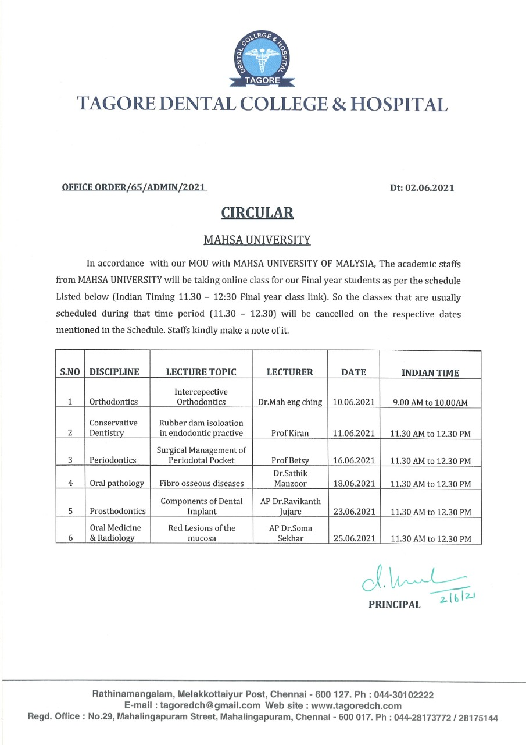

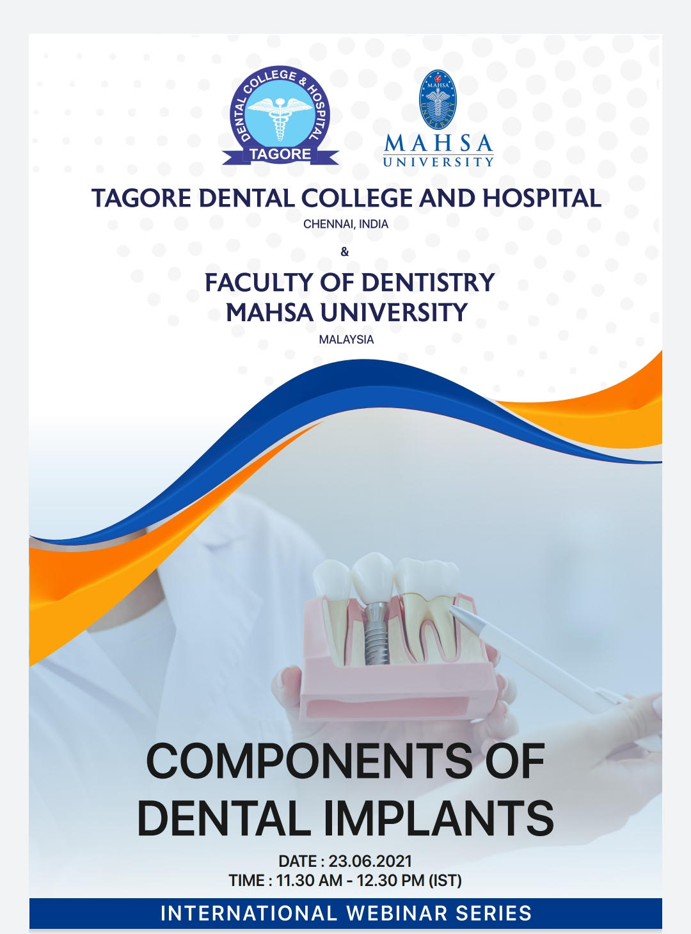

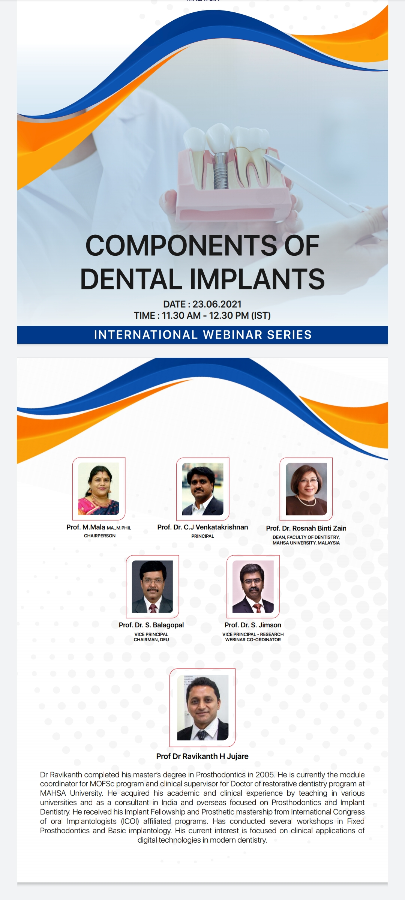

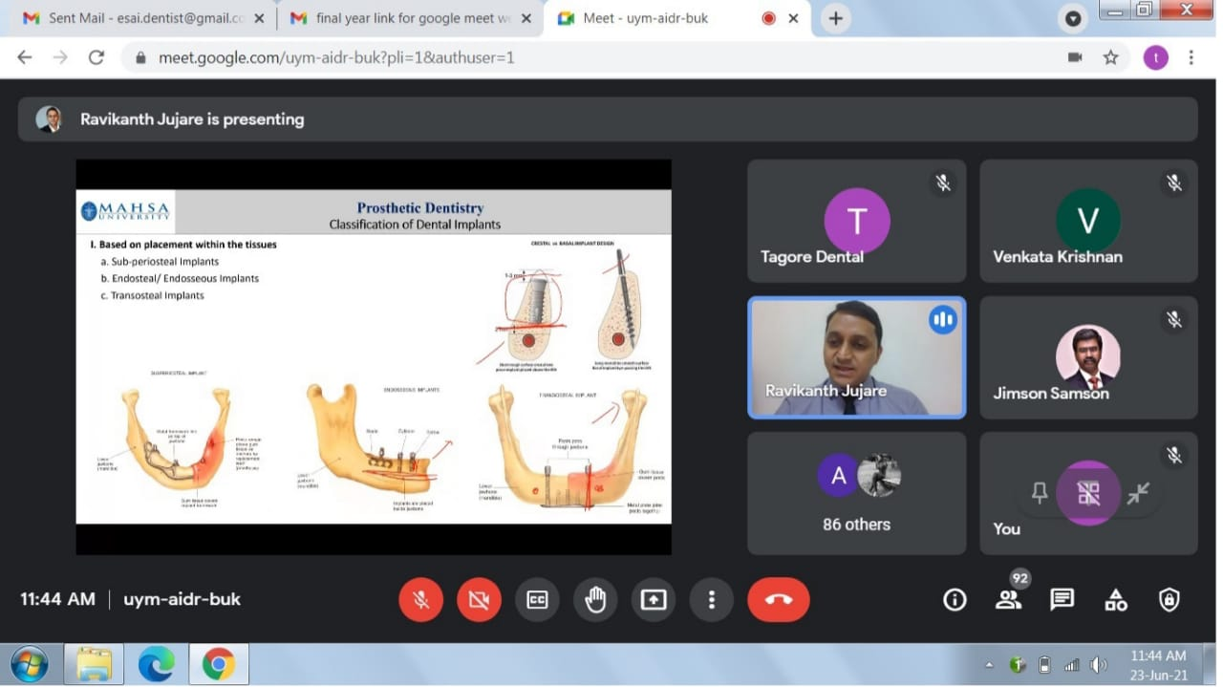

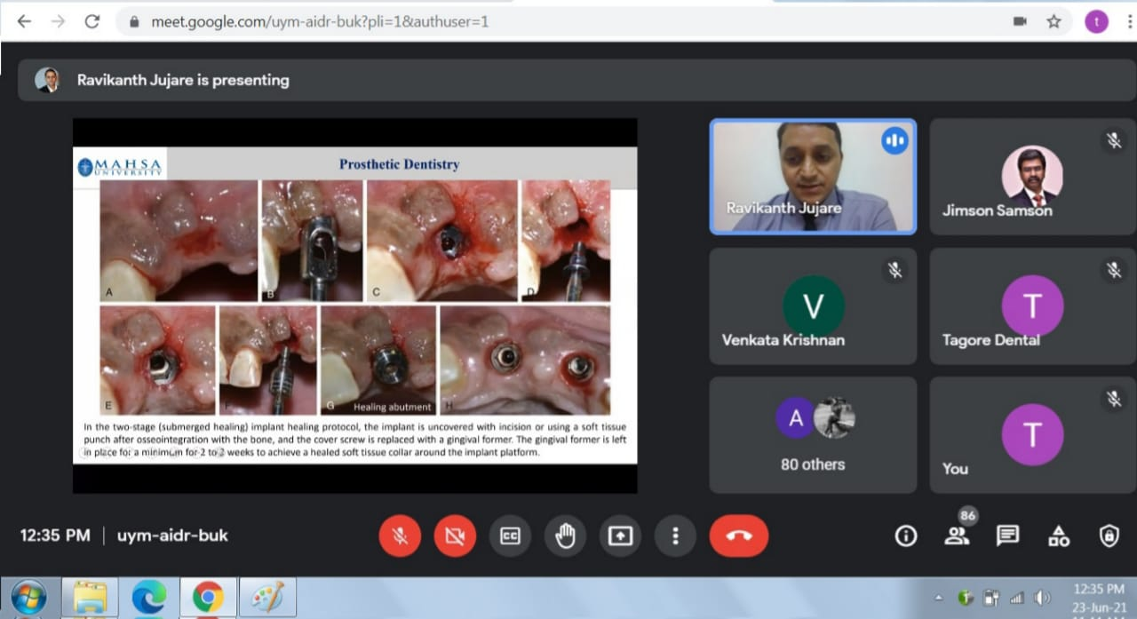

Final Years attendance list on 23/06/2021
- AARTHI P
- AARUDRADEVI J G
- ABHITHA SHREE S
- AISHWARYA K
- AISHWARYA S
- AJAI KUMAR
- AJITH KUMAR S
- AKASH V
- AKSHAYA N
- ANITHA ROSELIN S
- ANJALI V
- ANUSIYA J
- AYISHA M
- BAKYA LAKSHMI V
- BALAJI S A
- BHARANY MALAVIKA J
- BHARGAVI T
- BHAVANKUMAR V
- DEEPAK RAJ J
- DEEPIKA BARATHI M
- EZHIL BHARATHI I
- GAYATHRI V A M
- GOKULA PRIYA R
- GOPINATH B
- GOWARDHAN S
- HARITHA R
- JANANEE BHARKAVI N
- JANISHA M
- JEBASELVI P
- JEYAMITHA R
- KALKI PRIYA A
- KALPITA DEB BARMAN
- KAMIL HANEEF P
- KARTHIKEYAN A
- KRISHNAPRIYA R
- KRITHIKA A
- MALARVIZHI G
- MARIA SELVA VIVETHA A
- MONISHA N C
- MUTHU MEENAL M
- NAFEESA A
- NIRMALA S
- NISHA DAPHNE R
- NISHAALI M M
- PAVITHRA M
- POOJA DHARSHINI R
- PRAVINA
- PREETHA J H
- PRIYA S
- PUVITHA A
- RAGAPRIYA
- RAJ SHREE E
- RAKSHNA N
- RAMYA M
- RESHMA S
- RITHIKA SRI S
- SAROJINI M S
- SETHU SREE G
- SHARMILA E
- SHREEYAN NAYAR M N
- SHRIKAVI M
- SIVARANJANI S
- SREE LAKSHMI S
- SRIDEVI S
- SRIJANANI S
- STAVAN V
- SUBASH B
- SUBASH M
- SUGUMARI V
- SUMAIYA B
- SUMAIYA FATHIMA T
- SUTHAMANCHARRI S
- THILAKRAJ S
- VASANTHAN R M
- VETHIKA K
- VIVETHA

Absentes

- Aswini
- Fathima
- Kanmani
- Lakshyaa
- Sunil

Additional batch
Present:
1. Diwakar
2. Sudeeh
3. Avinash
4. Revati

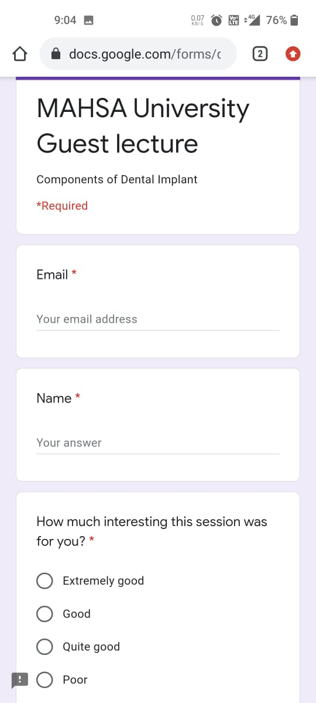
GOOGLE FORMS

